

STAGE 4 – ACCESSORIES

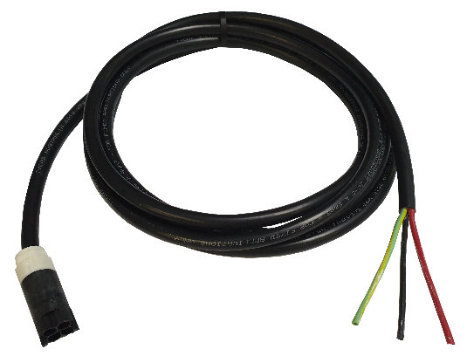
A1.1.3B6.000.3.XXX
Version 4.0 – January 2023

Description:
Connector Lead for Power/Lighting Circuits
3 Core x 2.5mm²
Low Fire Hazard (XLPE) Cable
Cable Colour: | Black

Please read instructions before commencing installation and retain for future reference.

Technical Specification:
Material: | Connector:
 | PA66 + 25% GF UL-94 V0 (S/N 704872-1)
 | PA66 unfilled UL-94 V2 (S/N 1573372-1)
Connector Dimensions: | 43.45mm (L) x ø 19mm (W)
Cable Insulation: | HFS-90-TP Sheath (BK)
Cable Rating: | 450/750V to AS/NZS 5000.2
Minimum Bending Radius: | Fixed: 60mm
 | During Installation: 90mm
Overall Cable Diameter: | 10.1mm
Maximum Operating Temperature: | 90°C
Enclosure Class: | IP20
Rated Current (A): | 20A
Power Outputs: | 4 Pole (3 Wire)
Rated Voltage (V): | 240V
Frequency (Hz): | 50Hz
Wire Size (mm²) | 2.5mm²
Weight: | 178g (based on 1m)
Wiring & Test Standard: | AS/NZS 3000
Connector Coupler Standard: | AS/NZS 61535:2011

